STAT 400 spring 2024 Multiple Linear Regression in-class exercise

Robert Stephen and Yinghao Tan

2. Waist Circumferences, picked this variable, because each variable has a p value of 0.00, secondly it has a VIF of 1, and the R square is 87.82%. Looking at all these factors, it is noticeable that “Waist” is a good factor for the response variable “BMI.”

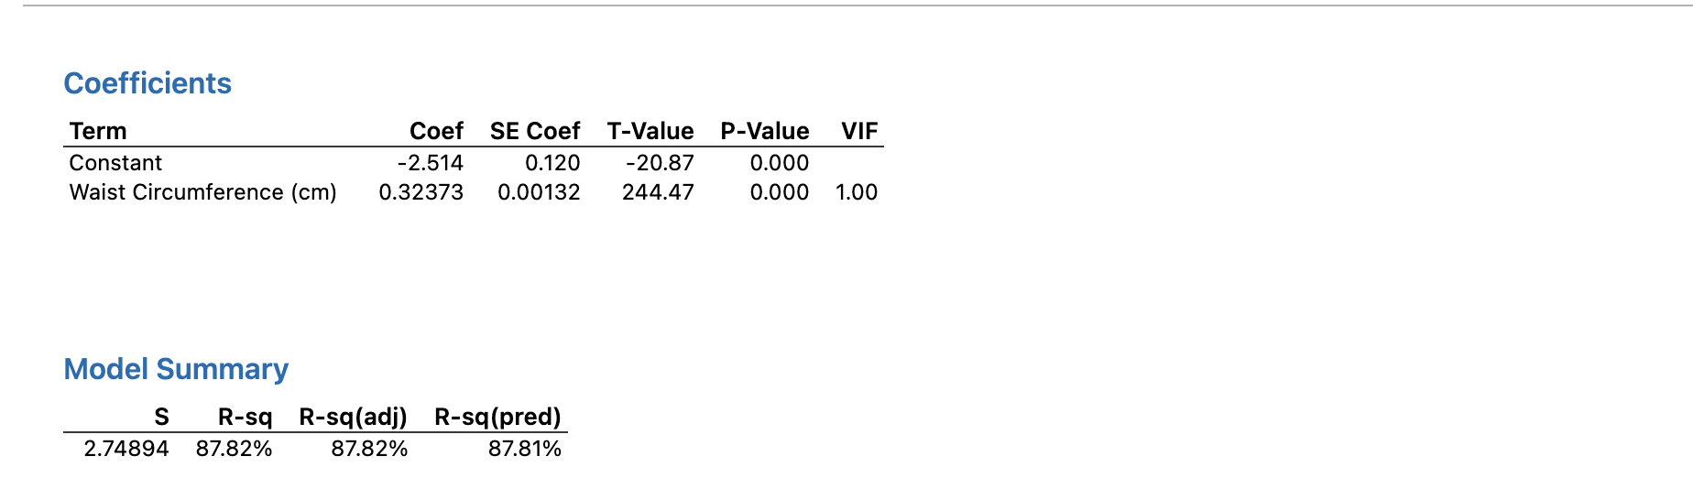

3. Diastolic: Blood Pressure (3rd rdg), Weight, Standing Height, chosen these variables because of there P value, VIF and R square. All the variables have a p value of 0.00. It has an S value of 1.297 which is lower than other variable comparisons. Also, it has a higher R square value percentage which is 97%. Hence “Blood Pressure” “Weight” and “Standing Height” are the better explanatory variables for response variable “BMI.”

